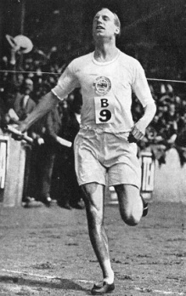

People of Faith
FaIth Matters

Is Honoring God Important?
"I believe God made me for a purpose; but He also made me fast. And when I run I feel His pleasure. To give it up would be to hold Him in contempt; to win is to honor Him." In 1924, at the age of 22, Eric Liddell was to run in the 100 meter dash, for which he had trained. A few days before the event, he discovered it was to be run on Sunday and he refused to run. Despite immense pressure, he decided not to compromise his convictions. A teammate on the British track and field team, Harold Abrahams, who was Jewish, suggested that he and Eric swap events. Eric agreed and entered in the 400 meter dash. A note was handed Eric just before the firing of the starter’s gun— “God honors those who honor him!” God honored Eric’s faithfulness winning the race and the Olympic gold medal, and setting a world record time in the 400 meter event, a record that stood for over a decade. (Harold Abrahams also won gold in the 100 meter!) Shortly after the Olympics Eric Liddell left to be a missionary in China, where he died in 1945 of a brain tumor in a Japanese prison camp just weeks before the camp was liberated by American troops and the war ended. His life was the subject of the movie "Chariots of Fire" which won the Oscar for Best Picture in 1982 and closes with these words— “Eric Liddell, missionary, died in occupied China at the end of World War II. All of Scotland mourned.”
Eric Liddell
“Whoever serves me must follow me; and where I am, my servant also will be. My Father will honor the one who serves me.” John 12:26
How can you honor God in your life?

What do you think would have happened if Eric had run the 100 meter dash instead?

