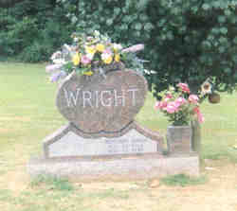

People of Faith
FaIth Matters

Taking Care of the Little Things ?
When moments of crisis come, and they will, a person’s true character is usually magnified. The coward displays cowardness. The skeptic unbelief. The person with little regard for the truth tells a lie. Likewise, the person who has learned unselfishness, consideration, and love for others often act bravely. Heroic soldiers have been know to throw themselves on a grenade to save fellow soldiers. Others have thrown themselves in front of a child when the sound gunfire is heard in a school. One such story tells of the selfless act of Shannon Wright. Her bravery cost her her life — but saved little Emma Pittman and was recounted in a story with the headline "Teacher’s heroic act was part of her character." I doubt that Mrs. Wright woke up that morning and decided that today she was going to be a hero. Instead I image that by taking care of the little things in her life, she was able to instinctly act in a noble and beautiful way. When the moment of crisis came she simply acted "in character". People who don’t discipline themselves in life’s "little things" seldom act virtuously or heroically when great moments of crisis come.
Shannon Wright
"Whoever can be trusted with very little can also be trusted with much, and whoever is dishonest with very little will also be dishonest with much.” Luke 16:10
Who is one person that you admire?

What are some little things you can do to build your faith?

