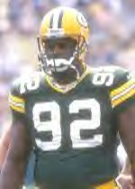

People of Faith
FaIth Matters

Who am I?
Interviewer: People identify you as a hero, but you're saying there's more to life than fame and fortune?
Reggie: God took a little boy from Chattanooga. I was a nobody. And He made me into somebody. Football wasn't the thing that made me into a somebody. It was allowing my character to be changed by Jesus, who made me into a somebody. I've asked kids, who do you want to be when you grow up? They say a football player, a doctor, lawyer, a bus driver, or whatever. I say I didn't ask what you wanted to do. Our kids are identifying themselves with what they want to do -- not who they are. We need to begin to allow them to see that Jesus knew who He was. People come to me and say you're a football player. Well, I tell them, "No," now. And the reason I tell them "No," is because football is what I did, it's not who I am. [Interview with Reggie White of Green Bay Packers]
Reggie White
“Do not conform to the pattern of this world, but be transformed by the renewing of your mind. Then you will be able to test and approve what God's will is--his good, pleasing and perfect will.” Romans 12:2
List the ways people would identify you?

Why do people end up being something other than what they dreamed of?

