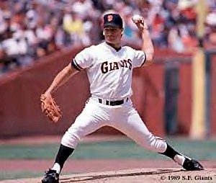

People of Faith
FaIth Matters

Seeds Grow Best in Good Soil
Dave Dravecky became a pitcher for San Francisco in 1987, being sidelined one season later with chronic pain in his left arm. A successful operation removed a malignant growth in his pitching arm and Dravecky returned the following season. His 4-3 defeat of the Cincinnati Reds on August 10, 1989 is remembered as one of the most awe-inspiring moments in baseball. Dave went from one of his greatest highs to a devastating low one week later when his arm shattered while pitching. “Just when my control began to slip in the sixth inning, an all-star batter stepped up to the plate. I got the signal for a sinking fastball, started my windup and--CRACK--when I released the ball, even the fans heard the bone in my arm snap. I lurched forward and immediately crumpled to the ground writhing with pain.” After several surgeries it was determined that his shoulder and pitching arm had to be removed to save his life. Dravecky recalled his thoughts “All control over my future, my security, my identity--everything--felt like it had been surgically removed along with my pitching arm. Yet in the midst of it all, a remarkable thing happened. God gave me hope in my brokenness and planted a seed that has changed my life.” National media coverage of his battle with cancer, provided Dave with the opportunity to share Christ. He and his wife used their story of hope to established the “Outreach of Hope Ministries”. They offer hope and encouragement to other patients suffering from cancer or amputations.
Dave Dravecky
“But the seed falling on good soil refers to someone who hears the word and understands it. This is the one who produces a crop, yielding a hundred, sixty or thirty times what was sown.” Matthew 13:23
Name some ways you can help others?

What can we do to make sure the soil of our lives is in good condition so the seeds of God can grow?

