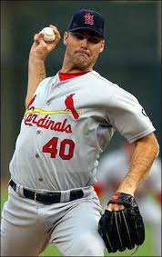
People of Faith
FaIth Matters

Does it matter what we believe about the Bible?
Andy Benes encountered God's will at the intersection of pride and family. The 6-foot-6 right-handed pitcher spent the 1996 and 1997 season as a stalwart for the St. Louis Cardinals, winning 28 games with an ERA of about 3.50.
“I believe the Bible is the inspired word of God. I believe it is without error. It is one of the ways to communicate with my heavenly father. That's His word and my guideline for how I'm supposed to live my life, treat my wife, communicate with her, raise my kids, how I'm supposed to treat my neighbor, my teammates.
My relationship with my heavenly Father is the most important thing in my life, and everything that is contained in the Bible is a way for me to help guide my life. You can't put a value on that. I’ve gone from being more selfish to hopefully being more selfless. God’s made me a champion for Christ.”
Andy
Benes
What areas of your life do you believe should be in line with the Bible?

Discuss a time when your belief about the Bible changed what you did?

