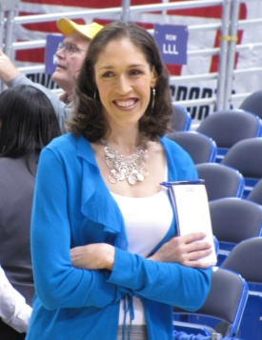

People of Faith
FaIth Matters

Action vs Words?
Rebecca Lobo-Rushin is an American television basketball analyst and former women's basketball player in the Women's National Basketball Association (WNBA) from 1997 to 2003. Her college years were spent at the University of Connecticut where, in her senior year, she helped lead the Huskies to the 1995 National Championship with an undefeated 35-0 record and won the 1995 Naismith and College Player of the Year award. Lobo (maiden name) also earned first team all American honors for both basketball and academics. She's close to her family and credits her dad with always offering love and support. Here is an excerpt from an interview with her from Readers Digest.
Rebecca Lobo-Rushin
rd.com: Describe your father.
Lobo: My father is an incredibly loving and caring man. He has very strong values and will fight for what he believes in. He always puts his faith and family first. I think his relationship with the Lord and his relationship with his family are more important to him than anything else in life.
rd.com: What's the best advice he ever gave you?
Lobo: He gave advice more through actions than words. Watching him pray, watching him treat my mother with incredible respect and love, watching him treat each person with dignity and equality. My father taught me how to be a good person.
What do your actions say about what you value?

What’s the best advice anyone ever gave you?

