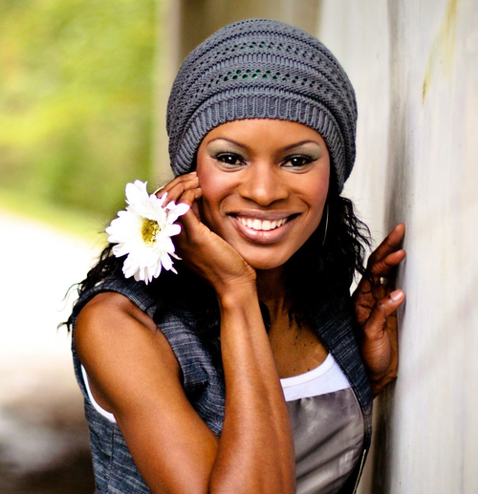

People of Faith
FaIth Matters

What’s Your Choice?
“Homemade” that’s what the girls on the school bus called Nicole C. Mullen. Every morning as she made her way to school she would hear it – “Homemade”. While family life was good, store-bought clothes were not the norm. So Nicole would wear clothes made for her by women at her church. "I wasn't cute," she says, “but I remember thinking, 'God still has a plan for me that these girls cannot touch.' I came to the conclusion that it really wasn’t up to the perpetrator to determine how I was going to turn out. It was up to me. The choice was mine. I could choose to forgive, and allow the Lord to heal the hurt, or I could choose to be a victim. I chose to forgive those girls, and because of that, God has changed me."
Nicole C.
Mullen
Nicole has become a successful Christian recording artist and the first African American artist to win the Dove Award for Song of the Year. "The world is looking for someone who believes in something," says singer/songwriter/choreographer/actress/youth advocate/mentor Nicole C. Mullen. "What do you believe in? I believe in Christ. And for that I will not apologize."
“For I am not ashamed of the gospel, because it is the power of God that brings salvation to everyone who believes: first to the Jew, then to the Gentile.” Romans 1:16
 Write about a time when you chose to forgive someone?

 Do you think we grow more from challenges or success?

