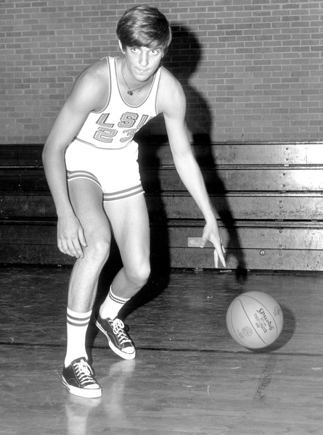

People of Faith
FaIth Matters

Is anything more important than faith?
For some it might be fame, a successful career, or even 30 pieces of silver. One might not ever know what they consider more important than Christ until faced with the decision.

Pete Maravich was an offensive genius, a crowd pleaser, and dynamic scorer. "He could do things with a basketball that I've never seen anybody do" admired Warriors great Rick Barry. He owns NCAA records for points in a season (1,381), points in a career (3,667), highest career scoring average (44.2 ppg), most field goals made in a career (1,387), and most field goals attempted (3,166). All of this without a three point shot!

When Pete Maravich collapsed suddenly on the basketball court during a recreational game with friends and died shortly afterwards at age 40 in 1988, his many friends and fans were stunned in disbelief. Ed Cheek recalls, "Not long before his death, he told his former coach, Richie Guerin, that his desire was to be remembered as a good Christian, a good husband, and a good father. Speaking at a Billy Graham Crusade in Columbia, S.C., a few months before his death, he said, "Next week I'll be inducted into the Hall of Fame. . . (but) I wouldn't trade my position in Christ for a thousand NBA championships, for a thousand Hall of Fame rings, or for a hundred billion dollars.'"
Pete Maravich

What do you want people to remember about you?

What choices are you making that might make people remember you some other way?

