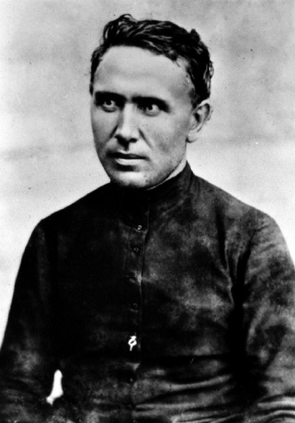
People of Faith
FaIth Matters

Transforming Service?

Ask any servant and the answer is usually the same, my service transformed me as much as it did those whom I served. Usually that transformation is not a physical one, but rather one that happens on the inside.

Father Damien is remembered most for his work among the lepers of Molokai, where both he and the people he served experienced a dramatic transformation. Living in the self-supporting leper colony to which all who had contracted the high-contagious disease, he knew that the government regulations required that he remain there for life and that he was almost certain to contract and die of the disease as well. In 1873 he boarded a ship carrying 50 lepers, and began the journey to Molokai where he was greeted by his new parishioners. He found appalling conditions with only one hopeful sign among the squalor of his new surroundings--a rude wooden chapel, where his first act was to kneel in prayer. He spent that night cleaning, and was disturbed by sounds that come with death, dying, and hopelessness. The days, months, and years that follow testify to the epic transformation he brought to this living hell. In 1885, at the age of 49 he himself caught the disease. Before he died, four other priests and a band of nurses had joined him, and under his influence the island of death became a civilized welfare community.
Father Damien

“Therefore we do not lose heart. Though outwardly we are wasting away, yet inwardly we are being renewed day by day.” 2 Corinthians 4:16

Describe one occasion when you volunteered to do something unpleasant.

Do you think this transformation could have occurred without Father Damien’s presence in the leper colony?

